Investigation into automatic scan time offset identification

Introduction

This report outlines the findings of a mini-investigation into automatic scan time offset identification. This is based on using the NIP2 image processing package to perform a basic edge detection routine and compare the number of “edge pixels” in each image. The image with the lowest number of edge pixels is selected as the best; here best means the image with the correct GPT offset. This selected GPT offset is then compared to the value as identified from a visual analysis of the data, which in turn is treated as the true value.

Processing

Eight sets of test data have been generated from UK Eagle flights. Each flight line has been processed 13 times with a different GPT offset applied. The GPT offsets applied can be seen on the attached spreadsheet in Table 1. Two of the flight lines (FL2 and FL5) had an extra GPT offset processed due to the fact that the visual GPT offset was not one of the generically applied ones. The spreadsheet also shows the number of edge pixels identified by NIP2.

The procedure for the NIP2 processing is as follows:

- Read in tif file & convert to greyscale
- Edge detect using combined vertical and horizontal sobel filter
- Threshold the data to keep “strong” edges and remove the weaker ones
- Count number of pixels that are non-zero valued (i.e. Pixels with an edge in)
- Repeat for each GPT offset image
- Select the result with the lowest non-zero pixel count

This is then repeated for the 8 flight lines.

Results

The results are not very promising. Out of the 8 data sets the NIP2 procedure agrees with the visual procedure for only one flight line (FL4). The magnitude of the difference between the NIP2 and visual timing offsets can be seen in Table 2 to range from 0 to 0.2 seconds. Figure 1 shows the image as selected by the NIP2 and the visual method for FL2. It can be seen that there are obvious errors in the NIP2 selected result. Figure 2 shows the corresponding images for FL5. The timing difference is 0.01 seconds, which can still be seen to have an effect on the data.

A subset of the flight lines have also had a fine GPT offset search applied to them. This allows a more clear view of what effect small scale GPT offsets have on the number of edge pixels. The results can be seen in Table 3 and and a plot of the scaled results in Figure 3. The outcome of this test suggests that the current method suffers due to noise. The final column of Table 3 is a separate test using a small crop of the image of FL2 to see if the method would work better over localised areas.

The conclusions of this series of tests are firstly that the NIP2 procedure, to be processingly feasible, would have to work in a 2 step arrangement – applying a coarse offset initially and then refining this offset. Without this style of procedure, too much processing would be required. Secondly the results suggest that the method doesn't work. Out of the 8 test lines NIP2 selected the correct offset 1 time. The method has also been shown to be sensitive to the area tested, with the small crop of FL2 giving a different solution to the full size FL2.

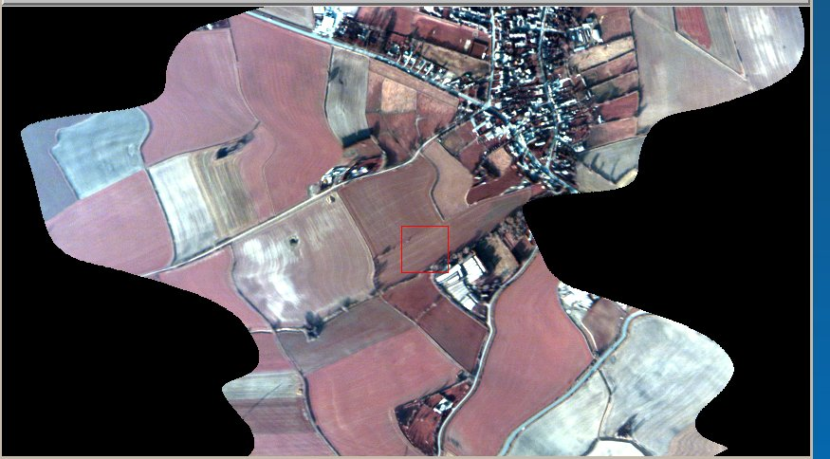
Fig 1a: Image identified by NIP2 as having best GPT offset for flight line 2
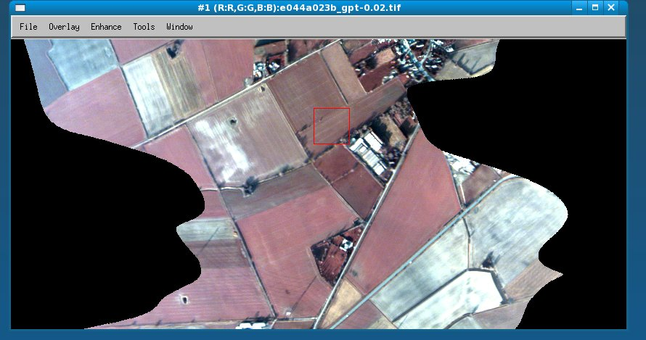
Fig 1b: Image identified visually as having best GPT offset for flight line 2
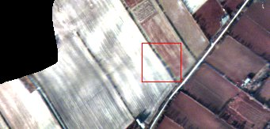
Fig 2a: Image identified by NIP2 as having best GPT offset for flight line 5

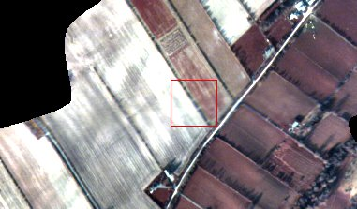
Fig 2b: Image identified visually as having best GPT offset for flight line 5

Fig 3. Plot of the fine offsets (normalised to GPT offset 0.0). Highlights that the current method is too imprecise/noisy.

