Investigation into frame buffer correction for GPT offset identification

Summary

The following summarises the findings of this investigation (please refer to the tables and figures below):

- Eagle
  - definite correlation between frame buffer correction and GPT offset.
  - Time offset between frame buffer correction (FBC) of 0 and -2 frames, and visual GPT agree to within 0.01s for 8/14 of flight lines – inconclusive as to whether the 0.01s is significant for the tested flight lines.
  - Another 4 of the Inverclyde lines could be conceivably better either with the FBC of -2 or an FBC of 0. With the terrain it is difficult to be sure.
  - FBC of -1 frame may be better than either visual GPT offset & FBC -2 or FBC of 0 for flight line 1 (FL1) of Loch Leven. FL2 is better with the a GPT offset. FL3 better with FBC=0.

- Hawk
  - FBC of -1 for Loch Leven flight lines and Inverclyde FL6 looks good. Difference in GPT times approximately 0.017 seconds.
  - Other flight lines are difficult to say with confidence if an FBC or GPT offset exists.
  - Nigg bay flight line 5 looks better with FBC=-3 applied. FL4 may look better with FBC of -1 frame. FL6 may look better with FBC of -2 frames. FL3 may be better with FBC=-2.

Introduction

This report summarises the findings from an investigation into the frame buffering correction and its relation to the GPT offset. The frame buffer correction (FBC) is the number of frames buffered between the camera and the frame grabber (definition from azimport -help command). The azimport software uses, as default, a frame buffer correction of 2 for Eagle and 3 for Hawk, but by using the -Ssy switch the user can enter a different value. We have an initial hypothesis:

“Eagle is operating with a FBC of -2 and Hawk with a FBC of -3. If we set these values to 0 and -1 respectively we remove the need to find GPT offset for the majority of cases.”

This has then been tested and comparisons between the results have been made. The test sites have used the available DEMs and vectors. It is important to note that both sensors can operate at different frame rates and therefore a frame offset of n scan lines can cause a GPT offset of varying degree.

Another important note is that a frame offset is not equivalent to a GPT offset, it also applies a shift to the data along the line of flight. (Therefore, strictly speaking, a frame offset is equivalent to a scan time offset rather than a GPT offset).

Method

The procedure for the investigation has been the following. Three previous flight days have been selected as test sites. These are all UK sites processed with a DEM. These sites have been previously processed and had visual GPT offsets identified for each flight line, which have been used as control for this investigation.

Each flight line has been processed using 3 (or more in some cases) combinations of GPT offsets and frame buffer corrections:

- default (Eagle: FBC 2 GPT 0, Hawk: FBC 3 GPT 0)
- visual GPT of n seconds if n is not equal to 0 (Eagle: FBC 2 GPT n, Hawk: FBC 3 GPT n)
- frame buffer correction x (Eagle/Hawk FBC x GPT 0)

For the frame offset process, this is initially tested with values of 0 for Eagle and -1 for Hawk, as outlined in the above hypothesis. If these values were not suitable then an iterative process takes place with the frame offset reduced by 1 each time. The frame buffer corrected result is compared to the visual GPT offset result (which is considered as truth).

Results

Inverclyde test site

This test site consists of 6 flight lines (FL) for both Eagle and Hawk sensors. The frame rate and timing offsets for the data can be seen in Table 1 in the spreadsheet, along with the GPT offset derived from a visual inspection. The first four flight lines are very difficult to examine as to which method is better, since the region is very mountainous and sparse of roads, fields etc which can be used to identify timing offsets. From table 1 it can be seen that for Eagle FL5 and FL6 the visual GPT and the time offset of 2 frames are very similar. But again it is very difficult to compare the 2 sets of images even with vectors overlaid. The figures below (Fig 1, 2 and 3) show features of some of the processed flight lines (FL) with the processing parameters labelled for visual comparison.

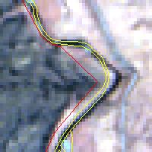  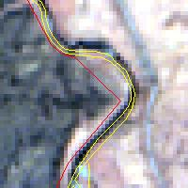  Figure 1  Eagle  FL5 |  | 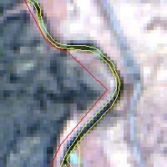
 | (a) { GPT=0 FBC=-2} | (b) {GPT -0.11 FBC=-2} | (c) { GPT=0 FBC=0}
Figure 2  Hawk  FL6 | 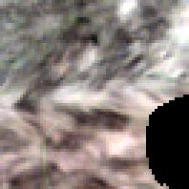 | 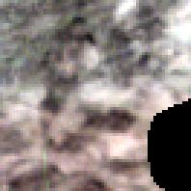 | 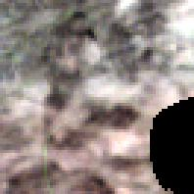
Figure 2  Hawk  FL6 | (a) { GPT=0 FBC=-3} | (b) { GPT= -0.1s FBC=-3} | (c) {GPT=0 FBC=-1}
Figure 3  Hawk  FL5 | 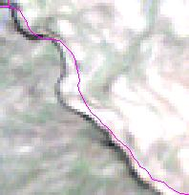 | 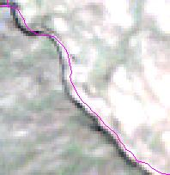 | 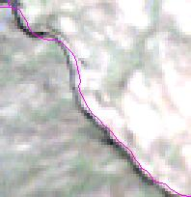
Figure 3  Hawk  FL5 | (a) {GPT 0 FBC -3} | (b) {GPT -0.05s FBC -3} | (c) {GPT 0 FBC -2}

Nigg Bay test site

This test site consists of 5 flight lines for both Eagle and Hawk sensors. The various flight line parameters can be seen in Table 2. It can be seen that, for Eagle, the visual GPT offset is equal to the time offset of 2 frames for each flight line. The figures below (Fig 4, 5 and 6) show features of some of the processed flight lines with the processing parameters labelled for visual comparison.

Figure 4  Eagle  FL3 | 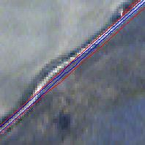 | 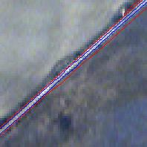 | 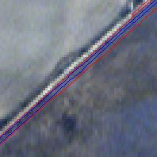
Figure 4  Eagle  FL3 | (a) {GPT=0 FBC=-2} | (b) {GPT=-0.1s FBC=-2} | (c) {GPT=0 FBC=0}
Figure 5  Hawk  FL3 | 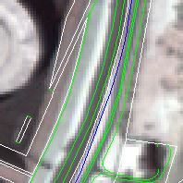 | 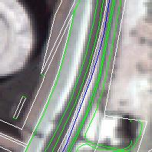 | 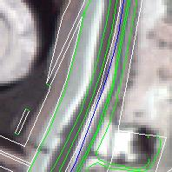
Figure 5  Hawk  FL3 | (a) {GPT=0 FBC=-3} | (b) {GPT=0 FBC=-2} | (c) {GPT=0 FBC=-1}
Figure 6  Hawk  FL6 | 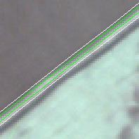 | 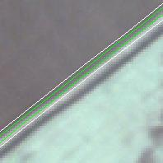 | 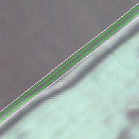
Figure 6  Hawk  FL6 | (a) {GPT=0 FBC=-3} | (b) {GPT=0 FBC=-2} | (c) {GPT=0 FBC=-1}

Loch Leven test site

This site consists of 3 flight lines for both Eagle and Hawk sensors. The parameters for the test site can be seen in Table 3. The figures below (Figs 7 to 12) show features of some of the processed flight lines with the processing parameters labelled for visual comparison.

Figure 7  Eagle  FL1 | 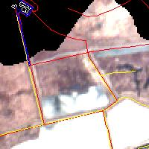 | 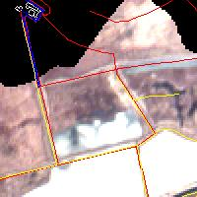 | 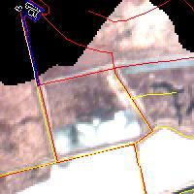
Figure 7  Eagle  FL1 | (a) {GPT=0 FBC=-2} | (b) {GPT=0 FBC=0} | (c) {GPT=0 FBC=-1}
Figure 8  Eagle  FL2 | 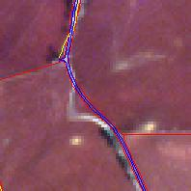 | 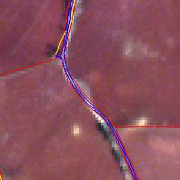 | 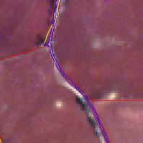
Figure 8  Eagle  FL2 | (a) {GPT 0 FBC -2} | (b) {GPT 0 FBC 0} | (c) {GPT 0 FBC -1}
Figure 8  Eagle  FL2 | 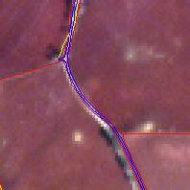 | 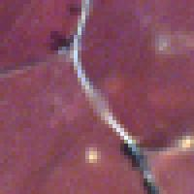
Figure 8  Eagle  FL2 | (d) {GPT -0.05s FBC -2} | (e) {GPT = 0.0167 FBC = 0}
Figure 9  Eagle  FL3 | 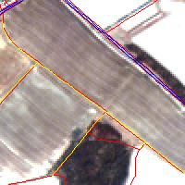 | 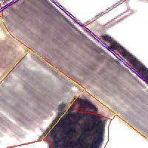 | 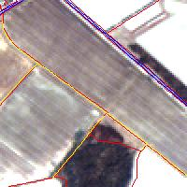
Figure 9  Eagle  FL3 | (a) {GPT=0 FBC=-2} | (b) {GPT=0 FBC=-1} | (c) {GPT=0 FBC=0}
Figure 9  Eagle  FL3 | 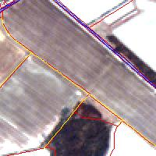
Figure 9  Eagle  FL3 | (d) {GPT=-0.1s FBC=-2}
Figure 10  Hawk  FL1 | 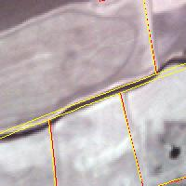 | 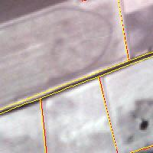 | 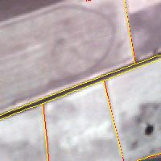
Figure 10  Hawk  FL1 | (a) {GPT=0 FBC=-3} | (b) {GPT=-0.1 FBC=-3} | (c) {GPT=0 FBC=-1}
Figure 11  Hawk  FL2 | 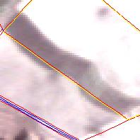 | 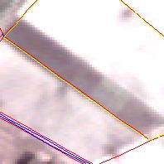 | 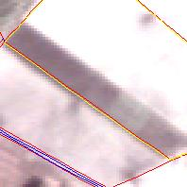
Figure 11  Hawk  FL2 | (a) {GPT=0 FBC=-3} | (b) {GPT=-0.125 FBC=-3} | (c) {GPT=0 FBC=-1}
Figure 12  Hawk  FL3 | 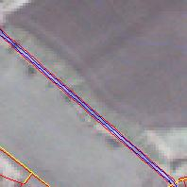 | 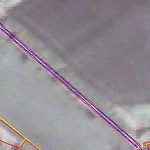 | 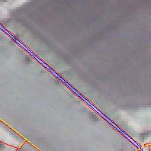
Figure 12  Hawk  FL3 | (a) {GPT=0 FBC=-3} | (b) {GPT=-0.1 FBC=-3} | (c) {GPT=0 FBC=-1}

Conclusions

Eagle conclusions

The conclusions of examining the Eagle flight lines are mixed. For the 3 test sites we get slightly different results. Test site 1 (Inverclyde) has 6 flight lines operating at 3 different frame rates. Two of the flight lines have GPT offsets derived visually that agree closely with the equivalent time offsets of a frame buffer correction of 2 frames magnitude. The images in figure 1 relate to one of these flight lines, FL5. For these two lines at least, it can be seen that a using FBC 0 frames is as good as FBC -2 with the GPT offset identified visually. But the frame buffer correction does add a geocoding error in the along track direction. The other four flight lines are inconclusive due to lack of identifiable features.

The Nigg Bay test site has 5 flight lines, with Eagle operating at 20 fps for each line, giving a GPT equivalent time of -0.1 seconds. This agrees with the visual inspection of the GPT offsets for each line. Figure 4 shows that {GPT -0.1 FBC -2} and {GPT 0 FBC 0} both remove the image distortions. Again there is a geocoding error consistent with a frame offset.

For the Loch Leven test site there were 3 flight lines, operating at 30 fps, and each line having a different visual GPT offset. Figure 7 shows crops of flight line 1. It appears from these that {GPT 0 FBC -1} may be a better solution than both {GPT 0 FBC -2} and {GPT 0 FBC 0}. Figure 8 shows FL2 results, and it appears that a GPT offset is best. An examination of FL3 (see Figure 9) shows that {GPT 0 FBC 0} agrees very closely with the visual truth {GPT -0.1 FBC -2}.

Hawk conclusions

The hawk sensor has been much more difficult to investigate. This is mainly due to the problem that distortions can be difficult to identify, especially at the finer offset level. It can be seen that by choosing a suitable FBC, images often appear similar to the GPT corrected ones, but choosing the “best” image from these 2 is difficult, e.g. see Figs. 5, 10, 11, 12.

Summary of flight lines

Key: * : Best option for flight line
- : broadly inconclusive
?: Either option could be good

Recommendations

For future Eagle processing it is recommended that a frame buffer correction of 0 is used (-Ssy 0 0 in azimport). If distortions are present in the lev3 product then test between 0 and - 2 FBC, since all offsets so far have been found to be 0 or negative. If distortions are still present in the data then use the FBC results to identify a ball-park GPT offset and apply a narrow band search with a FBC of 0. When suitable FBC values (or GPT offsets) have been identified, it is suggested that the -Ssy is removed and a corresponding GPT offset is applied as identified by the frame rate and FBC value, that is, use GPT = FBC / frame rate. This will remove the distortions without applying a shift to the data.

For future Hawk processing it is recommended to follow a similar process as for Eagle but apply a wider FBC offset of, say, 0 to -3. Hawk tends to be better with -Ssy 1 -1 or -Ssy 2 -1 but may also require GPT offsets to be applied.

